1. 8-QUEEN PROBLEM
Aim
To write a Python program to solve the 8-Queen problem using Backtracking.
Objective
To place 8 queens on an 8×8 chessboard so that no two queens attack each other.
Algorithm
- Create an empty 8×8 chessboard.
- Start from the first column.
- Place a queen in a safe row.
- Check rows and diagonals for safety.
- If safe, move to the next column.
- If no safe position exists, backtrack.
- Print the solution.
Python code:
N = 8
board = [["."] * N for _ in range(N)]
def safe(r, c):
for i in range(c):
if board[r][i] == "Q":
return False
i, j = r, c
while i >= 0 and j >= 0:
if board[i][j] == "Q":
return False
i -= 1
j -= 1
i, j = r, c
while i < N and j >= 0:
if board[i][j] == "Q":
return False
i += 1
j -= 1
return True
def solve(c):
if c == N:
return True
for r in range(N):
if safe(r, c):
board[r][c] = "Q"
if solve(c + 1):
return True
board[r][c] = "."
return False
solve(0)
for row in board:
print(*row)

Flowchart
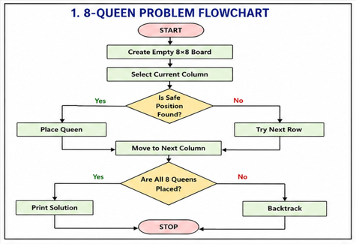
Output
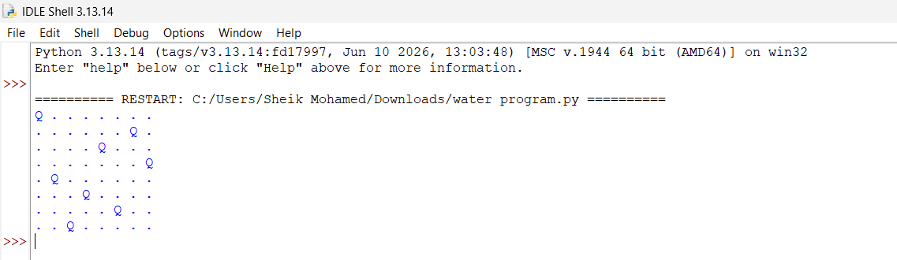
Result
Thus, the Python program to solve the 8-Queen problem was executed successfully.
Conclusion
The 8-Queen problem successfully solved

